# Progress

* Automated Abaqus run and data collection
* Investigated the effect of energy density and energy requirement
  + Energy density vs. maximum stress achieved
    - 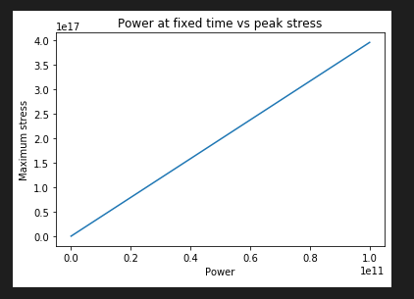
    - need to introduce non-linearity
  + Energy density vs. the amount of energy required to achieve certain stress
    - 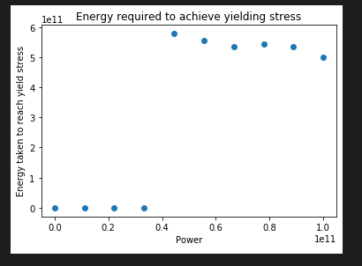
    - The energy required decreases when the power increases
  + Energy density vs. the distance between the location of peak stress and the boundary
    - 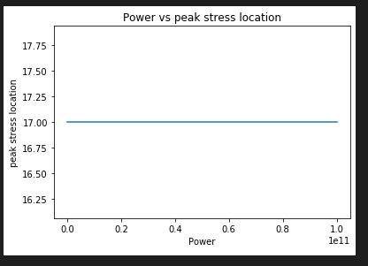
  + Evolving of peak stress location
    - 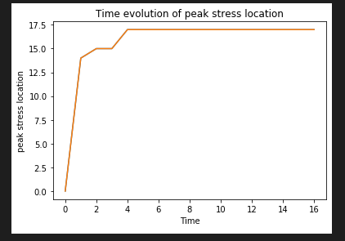
  + Time evolution of Peak stress value
    - 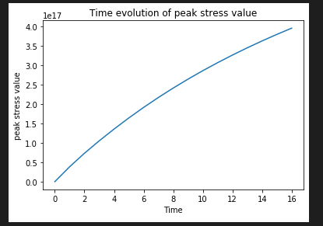
    - Stress do saturate at a point
* Generate random geometric distribution in Meep
* Performed simulation on random geometric distribution in Meep
* Generate same random geometric distribution in Abaqus
* Imported the output E field into Abaqus, academic teaching license cannot run user subroutines
* Look into UMAT
* Different distribution
* Use output database as boundary condition

Generate different natural occurrence for the rock and break it down in order to compare what is a reasonable value for the strength of the rock.